Lab 4
Task 1
select upper(airline_country) as airline_country_upper from airline;
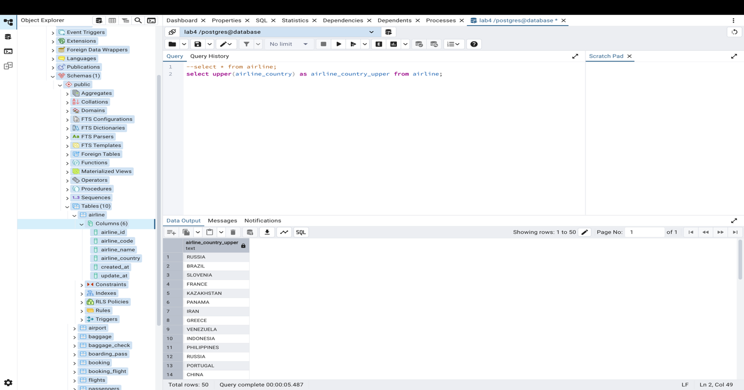

Task 2
select replace(airline_name,'Air','Aero') as new_airline from airline;
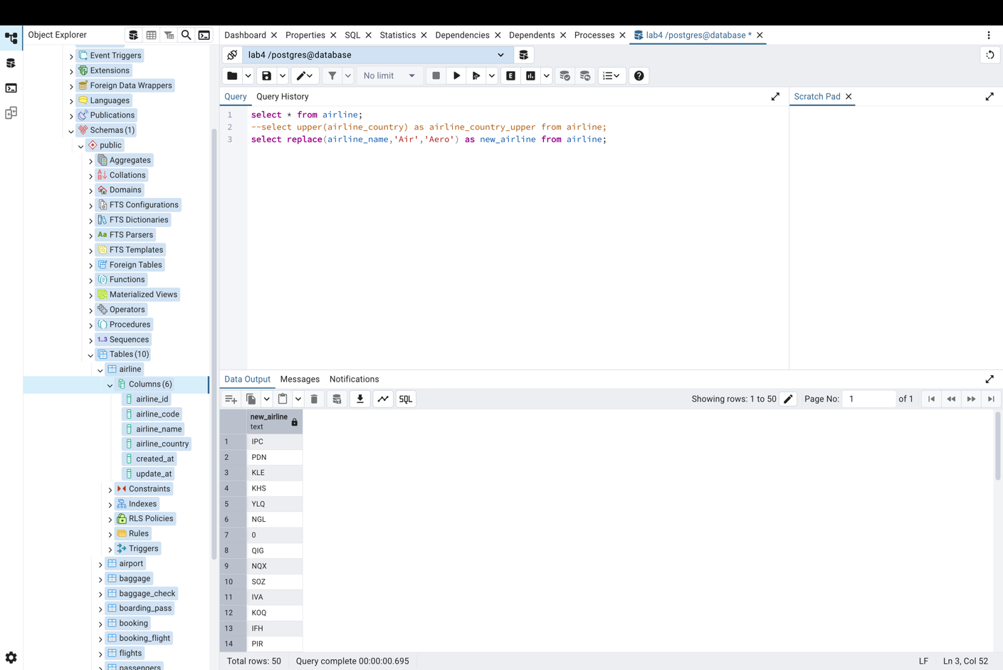
Task 3
SELECT flight_id
FROM flights
WHERE airline_id IN (1, 2)
GROUP BY flight_id
HAVING COUNT(DISTINCT airline_id) = 2;
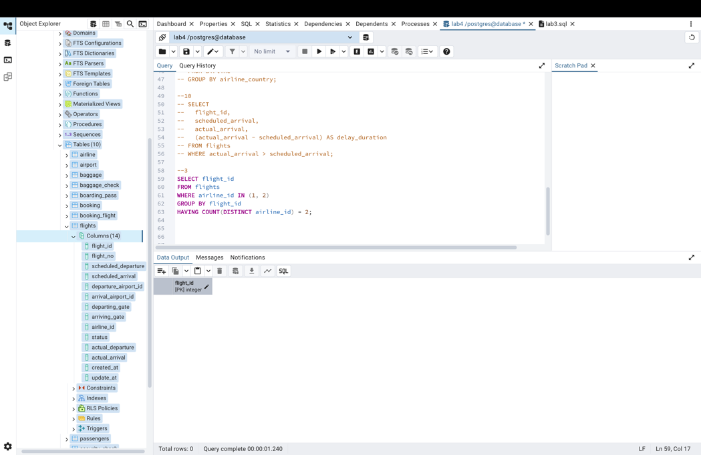
Task 4
SELECT *
FROM airport
WHERE airport_name LIKE '%Reginal%'
AND airport_name LIKE '%Air%';
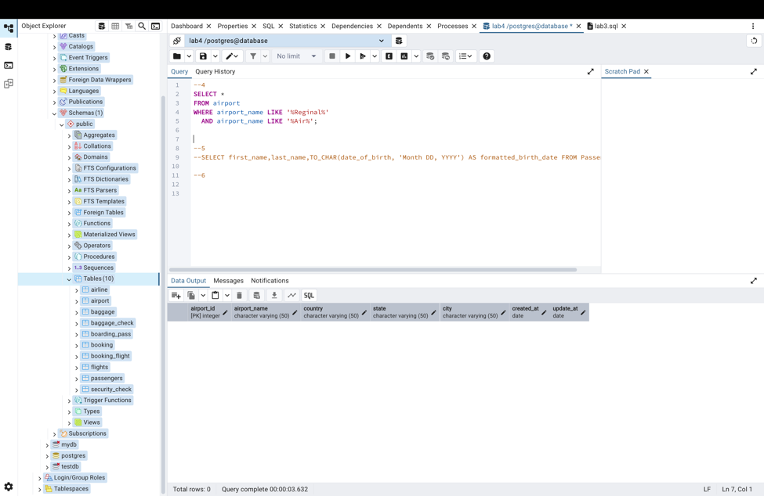

Task 5
SELECT first_name, last_name, TO_CHAR(date_of_birth, 'Month DD, YYYY') AS formatted_birth_date FROM Passengers;
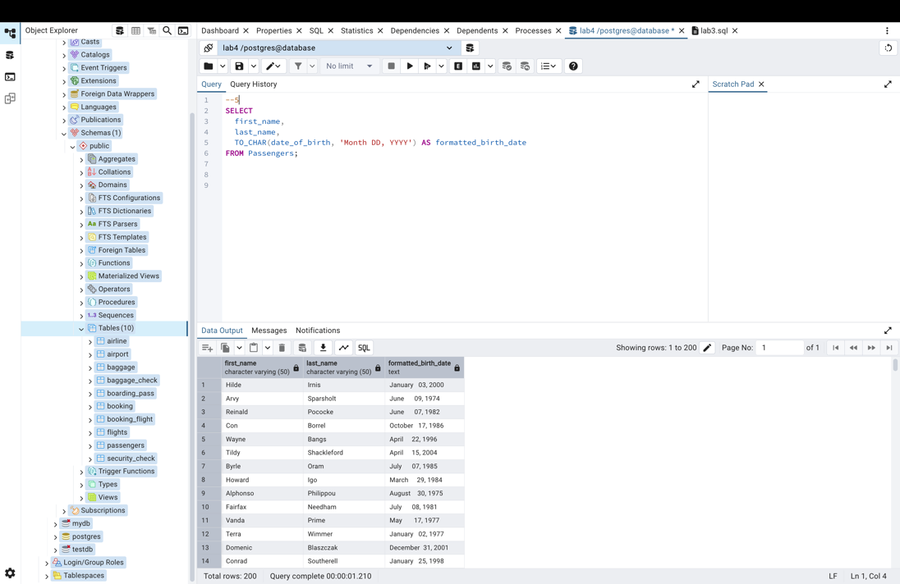

Task 6
SELECT flight_id,scheduled_arrival,actual_arrival FROM flights WHERE actual_arrival > scheduled_arrival;
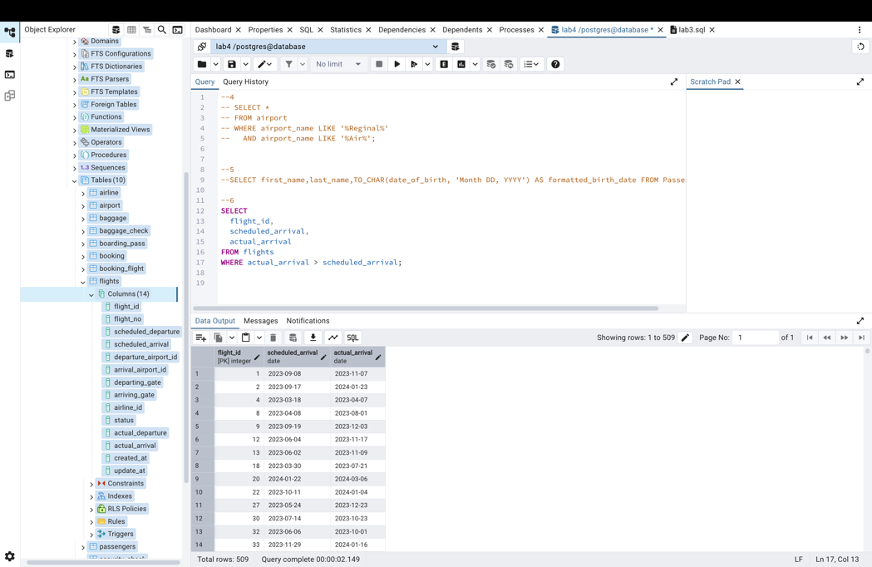
Task 7
SELECT
first_name,
last_name,
EXTRACT(YEAR FROM AGE(CURRENT_DATE, date_of_birth)) AS age,
CASE
WHEN EXTRACT(YEAR FROM AGE(CURRENT_DATE, date_of_birth)) BETWEEN 18 AND 35 THEN 'Young'
WHEN EXTRACT(YEAR FROM AGE(CURRENT_DATE, date_of_birth)) BETWEEN 36 AND 55 THEN 'Adult'
ELSE 'Other'
END AS age_group
FROM Passengers;
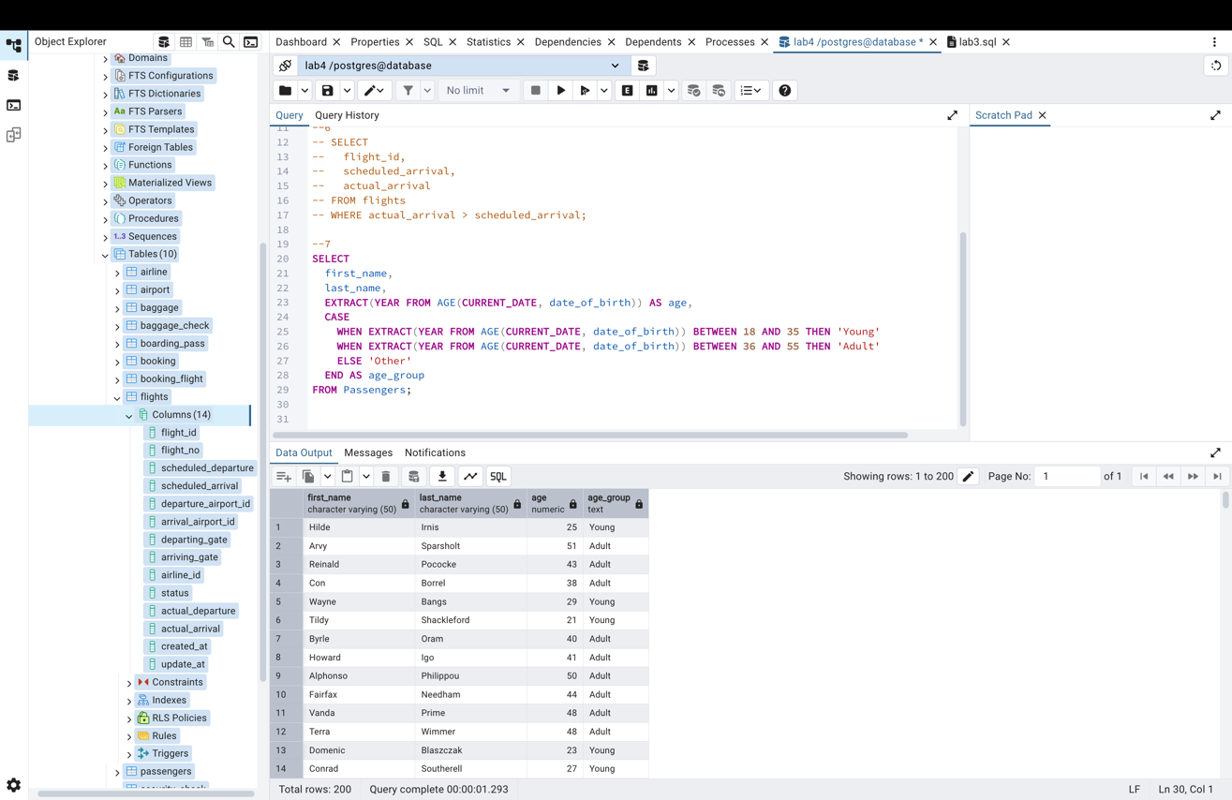
Task 8
SELECT
booking_id,
price,
CASE
WHEN price < 100 THEN 'Cheap'
WHEN price BETWEEN 100 AND 500 THEN 'Medium'
ELSE 'Expensive'
END AS price_category
FROM Booking;
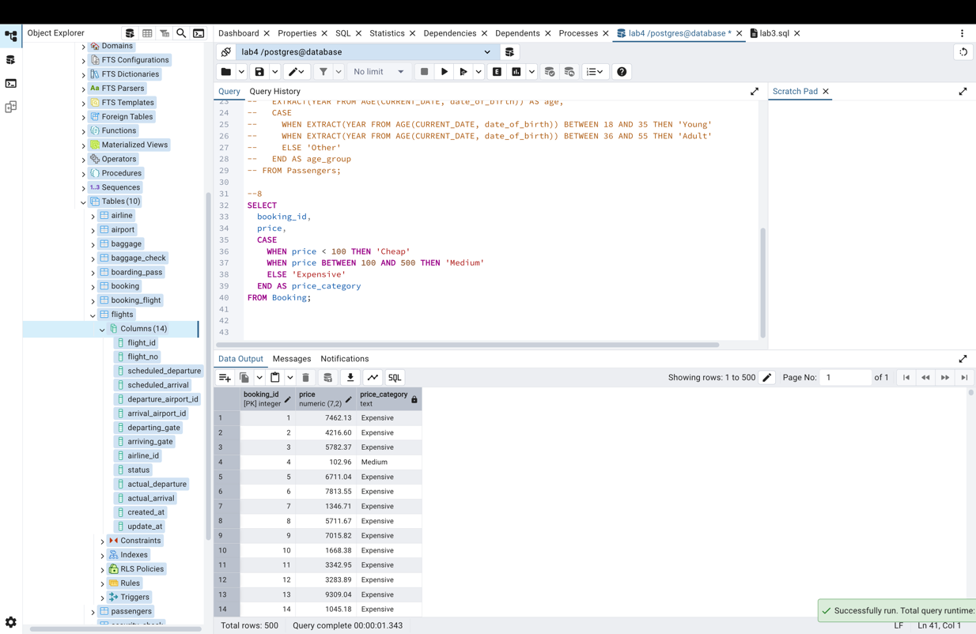
Task 9
SELECT
airline_country,
COUNT(airline_id) AS number_of_airlines
FROM airline
GROUP BY airline_country;
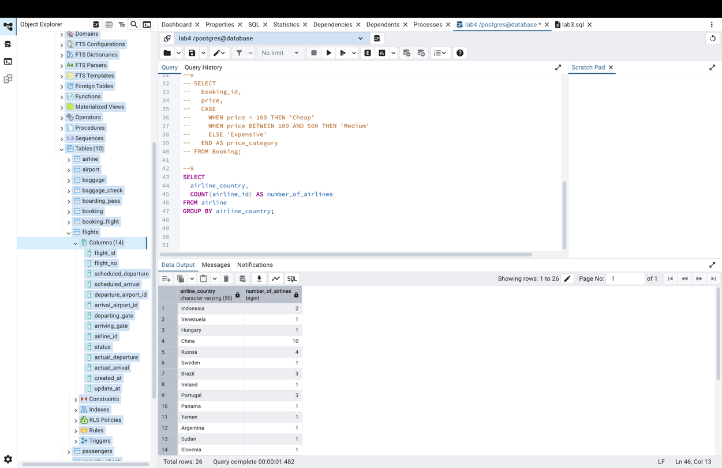
Task 10
SELECT
flight_id,
scheduled_arrival,
actual_arrival,
(actual_arrival - scheduled_arrival) AS delay_duration
FROM flights
WHERE actual_arrival > scheduled_arrival;
